**Disk Partitions**

lsblk -> To list all block devices (or) storage devices attached in server. For SATA & iSCSI disks, it uses ‘s’. For NVME disks, it uses same word ‘nvme’. For IDE disks, it uses ‘h’. Disk file type is block (‘b’ in permissions)

fdisk -l -> To get detail about all disks attached to server. Used to manage MBR disk.

fdisk -l /dev/sda -> To get detail about a particular disk attached in server. Here it is for disk sda. Used to manage MBR disk.

dmesg -> To get information related to disks. Like during boot time. Ex- dmesg | grep sda, dmesg |grep nvme etc.

lshw -> To get detail about attached hardware in server.

badblocks -ws /dev/sda -> To override data in storage to avoid original data recover in case of sale of storage.

dd if=/dev/zero of=/dev/sda -> Will replace all data with zeros.

Note: We can add SATA & SCSI drive in on the go i.e in running server. We can’t do with NVME & IDE type.

Note: To scan for newly added disks on running server during run-

ls /sys/class/scsi_host/ | while read host ; do echo "- - -" > /sys/class/scsi_host/$host/scan ; done

Note: MBR disk can have maximum of 4 primary partitions. Or 3 primary and 1 extended partition. Extended partition can further have 15 logical partitions. Fisk command is Used to manage MBR disk.

Note: GPT disk can have maximum of 128 primary partitions. gdisk command is Used to manage GPT disk.

Note: partprobe command is Used to manage both GPT & MBR disk.

cat /proc/partitions -> Detail about partitions on any disk along with disk.

MBR Disk Partition Steps Using fdisk:-

1. Check all blocks available.

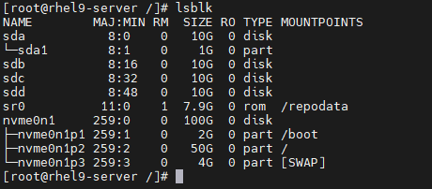

2. Creating MBR partition in disk sda.

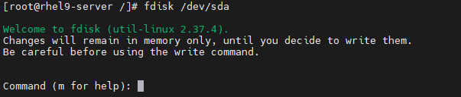

3. Add a new partition, use keyword n.

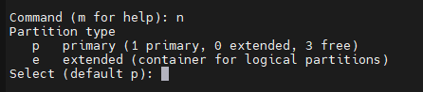

4. Type p for primary partition. Select no. 2 for new primary partition as 1 is already created. Keep first sector as it is & hit enter, use +2G to create 2GB partition & hit enter. Type will be default ‘Linux’. We can change it as per our requirement.

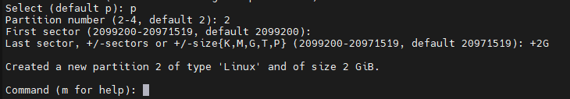

5. Type w and hit enter to save this partition.

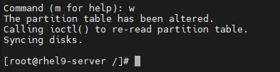

6. To verify, use lsblk command.

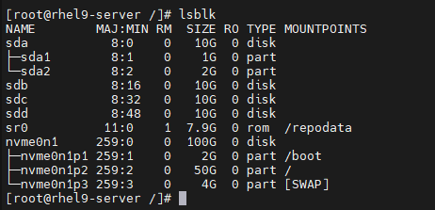

7. Next, we need to format this partition using xfs file system.

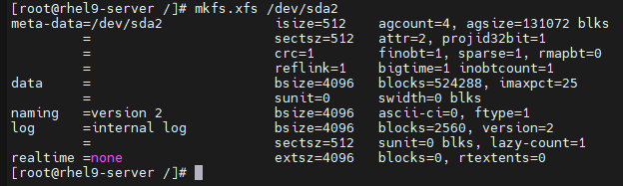

8. Next, mount this partition in /disks/waikiki_data_drive directory.



9. To confirm it, use df -Th.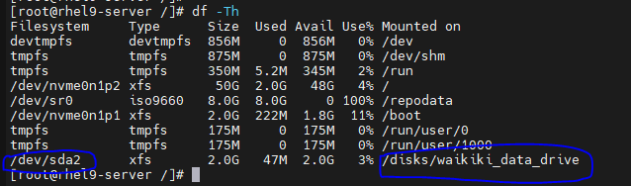

10. To unmount this partition, use umount command shown in screenshot.



11. Now verify it again using df -Th.

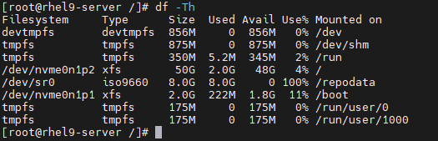

12. This mount will be temporary & get remove automatically once server reboot. To make it permanent, we need to add its entry in fstab file in etc directory in two ways.

(a) Using partition name.

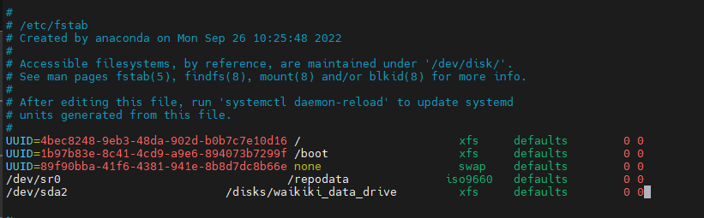

(b) Using Partition UUID.

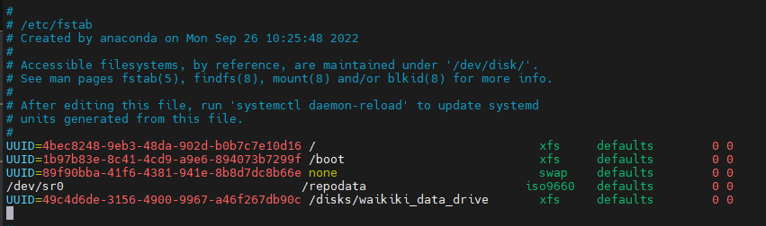

To get UUID, use two commands-

(i) lsblk -f

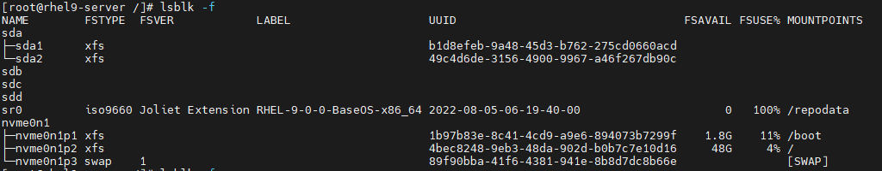

(ii) blkid /dev/sda2



GPT Disk Partition Steps Using gdisk:-

1. Check all blocks available

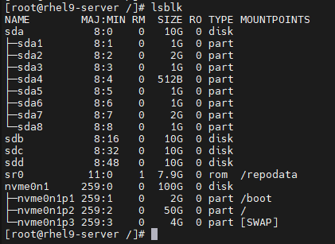

2. Creating MBR partition in disk sdb.

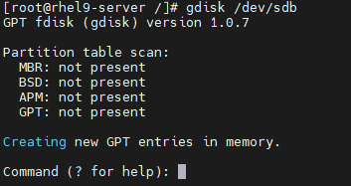

3. Add a new partition, use keyword n. Select no. 1 for new primary partition. Keep first sector as it is & hit enter, use +1G to create 1GB partition & hit enter. Type will be default ‘Linux Filesystems’. We can change it as per our requirement.

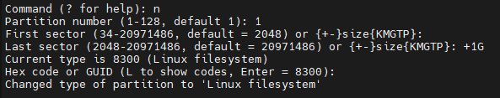

4. Type w and hit enter to save this partition. Now type Y to proceed.

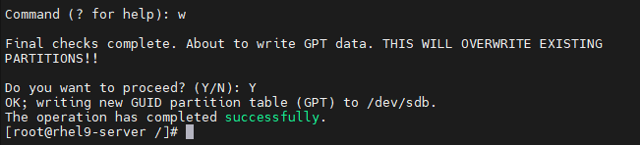

5. To verify, use lsblk command.

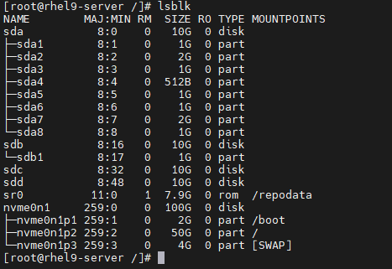

6. To check GPT disk detail, use gdisk -l /dev/sdb.

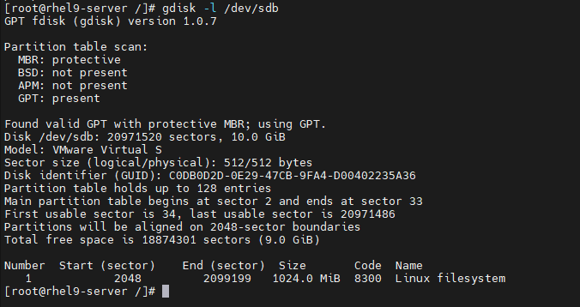

7. Next, we need to format this partition using xfs file system.

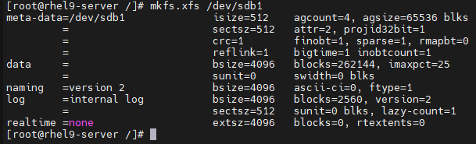

8. Next, mount this partition in /disks/banglore_data_drive directory.



9. Now verify it again using df -Th.

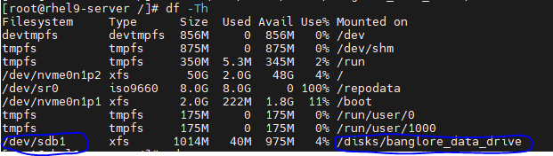

10. To unmount this partition, use umount command shown in screenshot.



11. Now verify it again using df -Th.

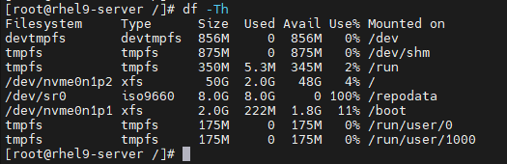

12. This mount will be temporary & get remove automatically once server reboot. To make it permanent, we need to add its entry in fstab file in etc directory in two ways. Please refer MBR disk partition steps to do this.